The Project Gutenberg EBook of Governor Winthrop's Return to Boston, by
G. Washington Warren

This eBook is for the use of anyone anywhere at no cost and with
almost no restrictions whatsoever. You may copy it, give it away or
re-use it under the terms of the Project Gutenberg License included
with this eBook or online at www.gutenberg.net

Title: Governor Winthrop's Return to Boston
An Interview with a Great Character

Author: G. Washington Warren

Release Date: April 6, 2011 [EBook #35777]

Language: English

Character set encoding: ISO-8859-1

*** START OF THIS PROJECT GUTENBERG EBOOK GOVERNOR WINTHROP'S RETURN ***

Produced by Al Haines

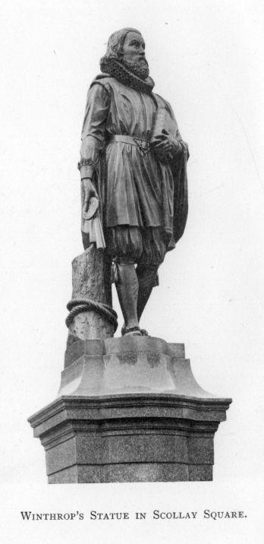

Winthrop's Statue in Scollay Square.

GOVERNOR WINTHROP'S RETURN TO BOSTON.

AN INTERVIEW
WITH
A GREAT CHARACTER.
A Poem

READ AT A SOCIAL MEETING OF FIRST CHURCH, AND
ALSO AT THE THURSDAY EVENING CLUB,
MARCH 25, APRIL 20, 1882.

BY G. WASHINGTON WARREN.

"Interviews are a modern species of literature, in which the author attempts to give a fancy sketch of the known or supposed opinions of the party interviewed."

BOSTON:
A. WILLIAMS AND COMPANY,
The Corner Bookstore
1883.

Three hundred copies printed.

Copyright, 1883,
BY G. WASHINGTON WARREN.

UNIVERSITY PRESS:
JOHN WILSON AND SON, CAMBRIDGE.

TO
ROBERT CHARLES WINTHROP,

THE DISTINGUISHED DESCENDANT OF

GOVERNOR JOHN WINTHROP,
A GENTLEMAN AND A SCHOLAR, A STATESMAN AND AN ORATOR,
IN WHOM THE VIRTUES OF HIS ILLUSTRIOUS ANCESTOR
ARE HAPPILY BLENDED,

This Little Book,

AS A SLIGHT TOKEN OF HIGH ESTEEM,
IS INSCRIBED
BY THE AUTHOR.

CONTENTS.

Governor Winthrop's Return to Boston

His Statue in Scollay Square
The Covenant of First Church
His Observations on his Return
The "Stocks" of his Time
The Changes since, and those which are to come
Rev. John Wilson's Vision
The Thursday Lecture and Thursday Club
President William B. Rogers and his Death
The new President of the Club
Josiah Quincy's Estimate of Winthrop
Winthrop's Life and Services

An Interview with a Great Character

Silence and Darkness in Scollay Square
Winthrop appears to the Writer
He disclaims being Venerable
Age not reckoned in Spirit-land
He refers to First Church and its History
And predicts its still Greater Success
The Winthrop Cup
New Things and Old
His Reflections on Wealth
The Example of John Harvard
The Spiritual the Substantial
The Proper Site of his Statue
Winthrop's Benediction and Departure

ILLUSTRATIONS.

WINTHROP'S STATUE IN SCOLLAY SQUARE … … Frontispiece

THE "STOCKS" OF THE OLDEN TIME

THE FIRST CHURCH, ON MARLBOROUGH STREET

PORTRAIT OF REV. JOHN WILSON

THE WINTHROP CUP

Governor Winthrop's Return to Boston.

On the seventeenth day of September, A.D. 1880, the two hundred and fiftieth anniversary of the foundation of the town of Boston, the event was commemorated, among other ways, by the inauguration of the statue of John Winthrop, in Scollay Square. He is represented by the renowned sculptor in the garb of a gentleman of his day, holding in his hand the royal charter of the Massachusetts Colony, which he brought over with him.

His serene countenance falls like a benediction upon this city of ours, which shows a wonderful and prosperous growth. He may be said to be the founder of the First Church of Boston, of the City itself, and of this Christian Commonwealth,—a threefold distinction. To have been the founder of a single one of these would have insured his immortal fame.
He was also the author of the covenant of the First Church, which was gathered in Charlestown, Aug. 27, 1630, and which soon after removed to the Boston side of Charles River. The covenant is in these words:—
"In the name of our Lord Jesus Christ, and in obedience to His holy and divine ordinance,—
"We, whose names are hereunder written, being by His most wise and good providence brought together into this part of America, in the Bay of Massachusetts, and desirous to unite ourselves into one congregation or church, under the Lord Jesus Christ, our Head, in such sort as becometh all those whom He hath redeemed and sanctified to Himself, do hereby solemnly and religiously (as in His most holy presence) promise and bind ourselves to walk in all our ways according to the rule of the Gospel and in all sincere conformity to His holy ordinances, and in mutual love and respect, each to other, so near as God shall give us grace."

Probably there are very few, if any, original documents in America of so ancient a date which have been preserved, and which are still in force, as this identical covenant, which has been signed and kept by hundreds in each generation for nearly three centuries. Far superior to the Andover creed, or to any other creed of seminary, council, or church, it has ever been a bond of union, and not a bone of contention. Aptly phrased and including all the essential conditions of a vital church organization, it will stand for centuries to come, and will outlast all creeds of human invention, ever promoting beneficence and charity.

This poem represents the spirit of Governor Winthrop returning to the city and the capital of the Christian Commonwealth he had founded, and taking possession of the bodily form which the artist has reproduced of him, clothed in his own antique costume. He surveys the extended limits of Boston, including Charlestown, with Bunker Hill Monument, and four other townships with hundreds of church steeples pointing to the sky. He misses from the old site on Cornhill the single house of worship where Wilson and Cotton preached, and where he was wont to expound; but soon he descries from afar, in his mind's eye, standing where, in his time, the waves of the sea were surging, the beautiful church edifice and the elegant chapel where five hundred Sunday-scholars are weekly taught. He dwells with supreme satisfaction upon the good deeds done by the church he established, and predicts for it a still more prosperous future and a greater spiritual growth. He recognizes only two things which existed in his day, and have remained unchanged,—the church covenant he wrote, as it were, by inspiration, or at least by a wise forecast of future needs, and the Communion cup he gave, which has singularly escaped the hazards of fire and the chances of time, and which has been, ever since, constantly used in the holy commemorative service.
Upon these almost universal changes he makes some appropriate reflections. To "sit in the stocks" was a punishment commonly imposed in his time for various offences. Richard Frothingham, in his "History of Charlestown," gives a view of the stocks that were set in the market-place with this mode of punishment applied. The view is here reproduced. "It was much used," says Frothingham, "and several times repaired. A sentence by the selectmen for 'drinking to excess,' shows that one hour's sitting in the stocks could be compromised by paying 3s. 4d. money." Winthrop, of course, would be struck with the different use of the word now so frequently spoken. From the fact that all investments of his day are swept out of existence, he predicts that the properties now held as most secure and reliable will in as long a time disappear. He illustrates the superiority of man, in his own best estate, to all worldly possessions.
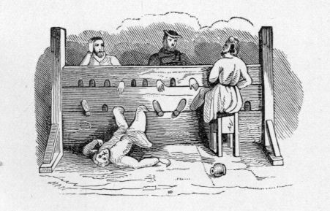

Sitting in the stocks

His allusion to the vision of Rev. John Wilson, the first minister of the church, recalls the following passage in his diary as quoted by Hon. Robert C. Winthrop in his "Life and Letters of John Winthrop," vol. 2, page 108.
"The pastor of Boston, Mr. Wilson, a very sincere, holy man, ... told the governour that, before he was resolved to come into this country, he dreamed he was here, and that he saw a church arise out of the earth, which grew up and became a marvellous goodly church."

The present church edifice well answers this description; built with exquisite taste after a most appropriate design, and bearing the palm of all the costly churches in the new part of Boston for fitness, beauty, and permanency.
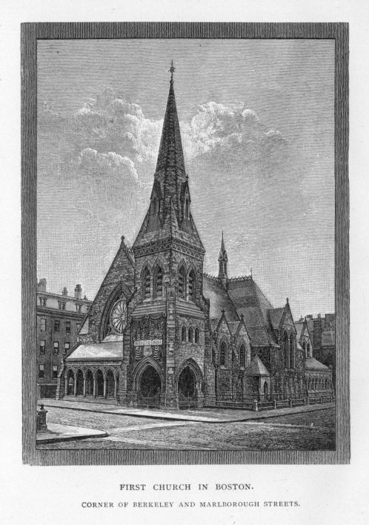

First Church in Boston. Corner of Berkeley and Marlborough Streets.
The Thursday Lecture, which was the special clerical and social occasion of his time, he finds abolished; and he observes that the Thursday Evening Club is now a characteristic feature of Boston. This was formed for social, scientific, and literary objects. Among its founders and early members were Edward Everett, a member of First Church, and Hon. Robert C. Winthrop, the distinguished descendant and representative of the Winthrop family. The one referred to in this interview as the then leader of the Club was its late President, William B. Rogers. He was a man of superior scientific attainments, with a power of apt expression and a felicity and fluency of utterance indeed remarkable. By his efforts and influence the Massachusetts Institute of Technology was established,—a lasting monument of his zeal for technical science, the most needed factor in popular education. In making an address to the Institute at its Commencement exercises, May 30, 1882, he was struck with death; he left the very place of his heart's and life's devotion for the spirit land of Winthrop. His predecessors in the office of President of the Club were John C. Warren, the nephew of General Joseph Warren, Edward Everett, J. Mason Warren, and Bishop Manton Eastburn. The historic mantle of the office has now been cast on Colonel Theodore Lyman, upon whose well-stored and lofty head honors have fallen thick, but no faster than merited.

Josiah Quincy the elder, the second on the roll of Boston's distinguished Mayors, declared that the City might well adopt Winthrop as its patron saint. His was an ideal, saintly life, and his character, in a sense, supernatural. He bore success and defeat in a political election with like equanimity, a trait that, as it were, by a law of heredity marks with special honor his living representative. Whether in office or out, and possessing large estates or, one after another, deprived of them, he kept his mind active and his brain industriously working for the development of a higher social life under Christian culture in a virgin land, by his leadership, under the Providence he devoutly acknowledged, to be fitted and fashioned for a new and powerful country, of which Boston was to be a memorable city.

Nor could he fail to remark upon the location of the statue set up in his honor in Scollay Square, rather than on Boston Common, which he had laid out and secured to posterity. The City Square in Charlestown, where he first unrolled the old charter of the Colony before the new government at its first meeting here, would have been a better site for it than the one selected.

Difficult it is, indeed, to set down in worthy lines the remembrance of the interview herein depicted. Of course, it has been faintly and inadequately done. Let us hope, however, that, should Winthrop's spirit, two or three centuries hence, visit again the last and most eventful scenes of his earthly life, he will find Boston, though changed anew, yet vastly improved, keeping pace with all developments for the good of an ever advancing race, and second to none in the Commonwealth or Nation in true excellence and progress.

AN INTERVIEW

WITH

A GREAT CHARACTER.

A Poem

POEM.

There was a quiet hour in Scollay Square;
The cars and teams were blocked from getting there;
No longer shone the famed electric light,—
It flickered out and left the darkest night.
I seemed to feel a shock upon my arm,
And hear the statue speak: "I 'll do no harm,—
An elder of First Church I think you are;
I have a message for you; come, prepare."
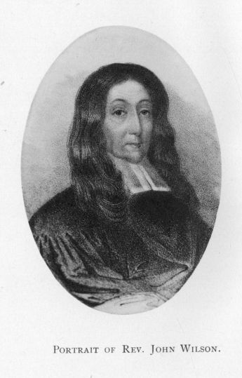

Portrait of Rev. John Wilson.
"Winthrop!" cried I, "my venerable sire!
Do you reanimate your rich attire?
Most glad am I to have this interview;
Pray, tell me all you wish, things old and new."
"My friend," said he, "no ven'rable am I,
For mortals grow no older when they die;
E'er since my earthly race I long have run,
My age has numbered only sixty-one.
Years are not counted on the heavenly shore,
For in eternal life time is no more.
The children sweet, the lovely bride forsooth,
Transferred, preserve the freshness of their youth.
Those who departed later are not found
Far to transcend them in their endless round.
More of the spirits' life I may not tell;
Enough to say that with them all is well;
God's universe has boundless worlds to show;
His works will take eternity to know.
"But I would speak of your millennial time
Whose fame has gone through yon celestial clime.
Almost one seventh of the years our Lord
Has named for Him, First Church has preached His word.
Its simple cov'nant ever served its need;
It learned to live without a cumbrous creed.
Its 'goodly church,' fast built where flowed the tide,
Fulfils the vision Wilson saw with pride.
Its charming chapel opens wide the door
To the bright children of the suffering poor.
Ah! blest are they who use for them their might!
Angels will bear them on their upward flight;
And, in return, the grateful youth will come,
With prosperous hands, to deck their Christian home.
The seed, wide-spread, will take its deepest root,
And, watered oft, will yield its tenfold fruit.
Erelong those hallowed walls will scarce contain
Those who shall flock to learn the precepts plain.
More week-day services will be required,
To hear the word by holy men inspired;
And long shall those enduring arches ring
With pulpit tones, and songs the choir will sing.
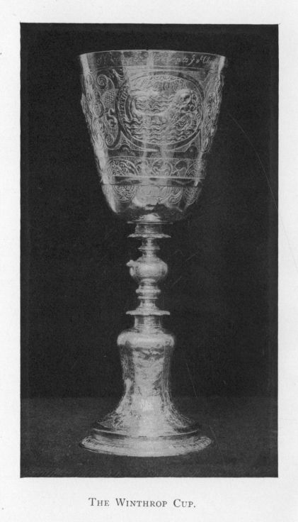

The Winthrop Cup.
"The cup I gave, and which you pass around,
The sole familiar thing about this ground,
Will prove a token true from age to age,—
May its partakers gild the sacred page!
"Oft as my after-knowledge takes wide range,
I note how wonderful the constant change:
No coin we used is current here to-day;
The bills we passed you would not take for pay.
Our money funds required no 'safety' locks,
And differs much what we and you call 'stocks;'
Men often find yours quite a dangerous game,
And get their foot stuck in them just the same.
"The Thursday Lecture yields no more its grace;
Your Thursday Evening Club now takes its place.
The buildings strong we built have ceased to be.
Lands now most valued then were in the sea.
And so, few centuries hence, 't will be again:
What now is property will sink like rain;
Your mills, railroads, and bonds will be out-played;
Then, too, your fruitful Calumet may fade.
Amass as much as one can call his own,
By right use only can its good be shown;
Pile worldly goods in a superfluous whole,
They are not worth e'en one immortal soul.
"'T was not my lot to have large sums in store,
My wealth was gone ere mortal life was o'er;
But Faith and Liberty I most did prize,—
On those twin rocks I bade a nation rise.
There was another John, you understand;
He founded Learning's halls in this new land;
Not Vanderbilt, nor any moneyed name
Will e'er outshine John Harvard's brilliant fame.
Learn this: strive not for wealth that will not last,
But let your treasures be in heaven cast;
These are alone the real things to crave.
While that will mould, like bodies in the grave,
Material forms to meet decay are sure;
The mind and spirit only will endure.
Hope's blissful visions, with its longings strong,
The will's high purpose, freed from thought of wrong,
Fond memory of good deeds that here were done,
Of sinners from their evil courses won,
The love and knowledge of the God Supreme,
Of Christ who came the fallen to redeem,—
These are, indeed, the good, substantial things
To which the soul for endless ages clings.
"Could I have marked where should this statue stand,
I would have placed it on that Common land,
Of past and coming times the great delight,—
With First Church spire and Capitol in sight;
My figure there should front the setting sun;
That, in review of any good I 've done
During the last score years I passed on earth,
Posterity may better know my worth.
"I love the grand First Church, I love the State.
I planted both. Their growth, through God, is great,
And both will flourish ever, while the sun
His circuit round this globe shall seem to run.
May every good Saint Botolph's town betide,
And Thursday Club, led by the wisest Guide."
Of what he said, this is, condensed, the sum.
Then flashed the light; on came the busy hum;
Then Winthrop's spirit soared up to the stars;
Mute stood his statue 'mid the noisy cars.

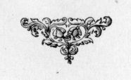

End of the Project Gutenberg EBook of Governor Winthrop's Return to Boston, by
G. Washington Warren

*** END OF THIS PROJECT GUTENBERG EBOOK GOVERNOR WINTHROP'S RETURN ***

***** This file should be named 35777-h.htm or 35777-h.zip *****
This and all associated files of various formats will be found in:
http://www.gutenberg.org/3/5/7/7/35777/

Produced by Al Haines

Updated editions will replace the previous one--the old editions
will be renamed.

Creating the works from public domain print editions means that no
one owns a United States copyright in these works, so the Foundation
(and you!) can copy and distribute it in the United States without
permission and without paying copyright royalties. Special rules,
set forth in the General Terms of Use part of this license, apply to
copying and distributing Project Gutenberg-tm electronic works to
protect the PROJECT GUTENBERG-tm concept and trademark. Project
Gutenberg is a registered trademark, and may not be used if you
charge for the eBooks, unless you receive specific permission. If you
do not charge anything for copies of this eBook, complying with the
rules is very easy. You may use this eBook for nearly any purpose
such as creation of derivative works, reports, performances and
research. They may be modified and printed and given away--you may do
practically ANYTHING with public domain eBooks. Redistribution is
subject to the trademark license, especially commercial
redistribution.

*** START: FULL LICENSE ***

THE FULL PROJECT GUTENBERG LICENSE
PLEASE READ THIS BEFORE YOU DISTRIBUTE OR USE THIS WORK

To protect the Project Gutenberg-tm mission of promoting the free
distribution of electronic works, by using or distributing this work
(or any other work associated in any way with the phrase "Project
Gutenberg"), you agree to comply with all the terms of the Full Project
Gutenberg-tm License (available with this file or online at
http://gutenberg.net/license).

Section 1. General Terms of Use and Redistributing Project Gutenberg-tm
electronic works

1.A. By reading or using any part of this Project Gutenberg-tm
electronic work, you indicate that you have read, understand, agree to
and accept all the terms of this license and intellectual property
(trademark/copyright) agreement. If you do not agree to abide by all
the terms of this agreement, you must cease using and return or destroy
all copies of Project Gutenberg-tm electronic works in your possession.
If you paid a fee for obtaining a copy of or access to a Project
Gutenberg-tm electronic work and you do not agree to be bound by the
terms of this agreement, you may obtain a refund from the person or
entity to whom you paid the fee as set forth in paragraph 1.E.8.

1.B. "Project Gutenberg" is a registered trademark. It may only be
used on or associated in any way with an electronic work by people who
agree to be bound by the terms of this agreement. There are a few
things that you can do with most Project Gutenberg-tm electronic works
even without complying with the full terms of this agreement. See
paragraph 1.C below. There are a lot of things you can do with Project
Gutenberg-tm electronic works if you follow the terms of this agreement
and help preserve free future access to Project Gutenberg-tm electronic
works. See paragraph 1.E below.

1.C. The Project Gutenberg Literary Archive Foundation ("the Foundation"
or PGLAF), owns a compilation copyright in the collection of Project
Gutenberg-tm electronic works. Nearly all the individual works in the
collection are in the public domain in the United States. If an
individual work is in the public domain in the United States and you are
located in the United States, we do not claim a right to prevent you from
copying, distributing, performing, displaying or creating derivative
works based on the work as long as all references to Project Gutenberg
are removed. Of course, we hope that you will support the Project
Gutenberg-tm mission of promoting free access to electronic works by
freely sharing Project Gutenberg-tm works in compliance with the terms of
this agreement for keeping the Project Gutenberg-tm name associated with
the work. You can easily comply with the terms of this agreement by
keeping this work in the same format with its attached full Project
Gutenberg-tm License when you share it without charge with others.

1.D. The copyright laws of the place where you are located also govern
what you can do with this work. Copyright laws in most countries are in
a constant state of change. If you are outside the United States, check
the laws of your country in addition to the terms of this agreement
before downloading, copying, displaying, performing, distributing or
creating derivative works based on this work or any other Project
Gutenberg-tm work. The Foundation makes no representations concerning
the copyright status of any work in any country outside the United
States.

1.E. Unless you have removed all references to Project Gutenberg:

1.E.1. The following sentence, with active links to, or other immediate
access to, the full Project Gutenberg-tm License must appear prominently
whenever any copy of a Project Gutenberg-tm work (any work on which the
phrase "Project Gutenberg" appears, or with which the phrase "Project
Gutenberg" is associated) is accessed, displayed, performed, viewed,
copied or distributed:

This eBook is for the use of anyone anywhere at no cost and with
almost no restrictions whatsoever. You may copy it, give it away or
re-use it under the terms of the Project Gutenberg License included
with this eBook or online at www.gutenberg.net

1.E.2. If an individual Project Gutenberg-tm electronic work is derived
from the public domain (does not contain a notice indicating that it is
posted with permission of the copyright holder), the work can be copied
and distributed to anyone in the United States without paying any fees
or charges. If you are redistributing or providing access to a work
with the phrase "Project Gutenberg" associated with or appearing on the
work, you must comply either with the requirements of paragraphs 1.E.1
through 1.E.7 or obtain permission for the use of the work and the
Project Gutenberg-tm trademark as set forth in paragraphs 1.E.8 or
1.E.9.

1.E.3. If an individual Project Gutenberg-tm electronic work is posted
with the permission of the copyright holder, your use and distribution
must comply with both paragraphs 1.E.1 through 1.E.7 and any additional
terms imposed by the copyright holder. Additional terms will be linked
to the Project Gutenberg-tm License for all works posted with the
permission of the copyright holder found at the beginning of this work.

1.E.4. Do not unlink or detach or remove the full Project Gutenberg-tm
License terms from this work, or any files containing a part of this
work or any other work associated with Project Gutenberg-tm.

1.E.5. Do not copy, display, perform, distribute or redistribute this
electronic work, or any part of this electronic work, without
prominently displaying the sentence set forth in paragraph 1.E.1 with
active links or immediate access to the full terms of the Project
Gutenberg-tm License.

1.E.6. You may convert to and distribute this work in any binary,
compressed, marked up, nonproprietary or proprietary form, including any
word processing or hypertext form. However, if you provide access to or
distribute copies of a Project Gutenberg-tm work in a format other than
"Plain Vanilla ASCII" or other format used in the official version
posted on the official Project Gutenberg-tm web site (www.gutenberg.net),
you must, at no additional cost, fee or expense to the user, provide a
copy, a means of exporting a copy, or a means of obtaining a copy upon
request, of the work in its original "Plain Vanilla ASCII" or other
form. Any alternate format must include the full Project Gutenberg-tm
License as specified in paragraph 1.E.1.

1.E.7. Do not charge a fee for access to, viewing, displaying,
performing, copying or distributing any Project Gutenberg-tm works
unless you comply with paragraph 1.E.8 or 1.E.9.

1.E.8. You may charge a reasonable fee for copies of or providing
access to or distributing Project Gutenberg-tm electronic works provided
that

- You pay a royalty fee of 20% of the gross profits you derive from
the use of Project Gutenberg-tm works calculated using the method
you already use to calculate your applicable taxes. The fee is
owed to the owner of the Project Gutenberg-tm trademark, but he
has agreed to donate royalties under this paragraph to the
Project Gutenberg Literary Archive Foundation. Royalty payments
must be paid within 60 days following each date on which you
prepare (or are legally required to prepare) your periodic tax
returns. Royalty payments should be clearly marked as such and
sent to the Project Gutenberg Literary Archive Foundation at the
address specified in Section 4, "Information about donations to
the Project Gutenberg Literary Archive Foundation."

- You provide a full refund of any money paid by a user who notifies
you in writing (or by e-mail) within 30 days of receipt that s/he
does not agree to the terms of the full Project Gutenberg-tm
License. You must require such a user to return or
destroy all copies of the works possessed in a physical medium
and discontinue all use of and all access to other copies of
Project Gutenberg-tm works.

- You provide, in accordance with paragraph 1.F.3, a full refund of any
money paid for a work or a replacement copy, if a defect in the
electronic work is discovered and reported to you within 90 days
of receipt of the work.

- You comply with all other terms of this agreement for free
distribution of Project Gutenberg-tm works.

1.E.9. If you wish to charge a fee or distribute a Project Gutenberg-tm
electronic work or group of works on different terms than are set
forth in this agreement, you must obtain permission in writing from
both the Project Gutenberg Literary Archive Foundation and Michael
Hart, the owner of the Project Gutenberg-tm trademark. Contact the
Foundation as set forth in Section 3 below.

1.F.

1.F.1. Project Gutenberg volunteers and employees expend considerable
effort to identify, do copyright research on, transcribe and proofread
public domain works in creating the Project Gutenberg-tm
collection. Despite these efforts, Project Gutenberg-tm electronic
works, and the medium on which they may be stored, may contain
"Defects," such as, but not limited to, incomplete, inaccurate or
corrupt data, transcription errors, a copyright or other intellectual
property infringement, a defective or damaged disk or other medium, a
computer virus, or computer codes that damage or cannot be read by
your equipment.

1.F.2. LIMITED WARRANTY, DISCLAIMER OF DAMAGES - Except for the "Right
of Replacement or Refund" described in paragraph 1.F.3, the Project
Gutenberg Literary Archive Foundation, the owner of the Project
Gutenberg-tm trademark, and any other party distributing a Project
Gutenberg-tm electronic work under this agreement, disclaim all
liability to you for damages, costs and expenses, including legal
fees. YOU AGREE THAT YOU HAVE NO REMEDIES FOR NEGLIGENCE, STRICT
LIABILITY, BREACH OF WARRANTY OR BREACH OF CONTRACT EXCEPT THOSE
PROVIDED IN PARAGRAPH 1.F.3. YOU AGREE THAT THE FOUNDATION, THE
TRADEMARK OWNER, AND ANY DISTRIBUTOR UNDER THIS AGREEMENT WILL NOT BE
LIABLE TO YOU FOR ACTUAL, DIRECT, INDIRECT, CONSEQUENTIAL, PUNITIVE OR
INCIDENTAL DAMAGES EVEN IF YOU GIVE NOTICE OF THE POSSIBILITY OF SUCH
DAMAGE.

1.F.3. LIMITED RIGHT OF REPLACEMENT OR REFUND - If you discover a
defect in this electronic work within 90 days of receiving it, you can
receive a refund of the money (if any) you paid for it by sending a
written explanation to the person you received the work from. If you
received the work on a physical medium, you must return the medium with
your written explanation. The person or entity that provided you with
the defective work may elect to provide a replacement copy in lieu of a
refund. If you received the work electronically, the person or entity
providing it to you may choose to give you a second opportunity to
receive the work electronically in lieu of a refund. If the second copy
is also defective, you may demand a refund in writing without further
opportunities to fix the problem.

1.F.4. Except for the limited right of replacement or refund set forth
in paragraph 1.F.3, this work is provided to you 'AS-IS' WITH NO OTHER
WARRANTIES OF ANY KIND, EXPRESS OR IMPLIED, INCLUDING BUT NOT LIMITED TO
WARRANTIES OF MERCHANTIBILITY OR FITNESS FOR ANY PURPOSE.

1.F.5. Some states do not allow disclaimers of certain implied
warranties or the exclusion or limitation of certain types of damages.
If any disclaimer or limitation set forth in this agreement violates the
law of the state applicable to this agreement, the agreement shall be
interpreted to make the maximum disclaimer or limitation permitted by
the applicable state law. The invalidity or unenforceability of any
provision of this agreement shall not void the remaining provisions.

1.F.6. INDEMNITY - You agree to indemnify and hold the Foundation, the
trademark owner, any agent or employee of the Foundation, anyone
providing copies of Project Gutenberg-tm electronic works in accordance
with this agreement, and any volunteers associated with the production,
promotion and distribution of Project Gutenberg-tm electronic works,
harmless from all liability, costs and expenses, including legal fees,
that arise directly or indirectly from any of the following which you do
or cause to occur: (a) distribution of this or any Project Gutenberg-tm
work, (b) alteration, modification, or additions or deletions to any
Project Gutenberg-tm work, and (c) any Defect you cause.

Section 2. Information about the Mission of Project Gutenberg-tm

Project Gutenberg-tm is synonymous with the free distribution of
electronic works in formats readable by the widest variety of computers
including obsolete, old, middle-aged and new computers. It exists
because of the efforts of hundreds of volunteers and donations from
people in all walks of life.

Volunteers and financial support to provide volunteers with the
assistance they need are critical to reaching Project Gutenberg-tm's
goals and ensuring that the Project Gutenberg-tm collection will
remain freely available for generations to come. In 2001, the Project
Gutenberg Literary Archive Foundation was created to provide a secure
and permanent future for Project Gutenberg-tm and future generations.
To learn more about the Project Gutenberg Literary Archive Foundation
and how your efforts and donations can help, see Sections 3 and 4
and the Foundation web page at http://www.pglaf.org.

Section 3. Information about the Project Gutenberg Literary Archive
Foundation

The Project Gutenberg Literary Archive Foundation is a non profit
501(c)(3) educational corporation organized under the laws of the
state of Mississippi and granted tax exempt status by the Internal
Revenue Service. The Foundation's EIN or federal tax identification
number is 64-6221541. Its 501(c)(3) letter is posted at
http://pglaf.org/fundraising. Contributions to the Project Gutenberg
Literary Archive Foundation are tax deductible to the full extent
permitted by U.S. federal laws and your state's laws.

The Foundation's principal office is located at 4557 Melan Dr. S.
Fairbanks, AK, 99712., but its volunteers and employees are scattered
throughout numerous locations. Its business office is located at
809 North 1500 West, Salt Lake City, UT 84116, (801) 596-1887, email
business@pglaf.org. Email contact links and up to date contact
information can be found at the Foundation's web site and official
page at http://pglaf.org

For additional contact information:
Dr. Gregory B. Newby
Chief Executive and Director
gbnewby@pglaf.org

Section 4. Information about Donations to the Project Gutenberg
Literary Archive Foundation

Project Gutenberg-tm depends upon and cannot survive without wide
spread public support and donations to carry out its mission of
increasing the number of public domain and licensed works that can be
freely distributed in machine readable form accessible by the widest
array of equipment including outdated equipment. Many small donations
($1 to $5,000) are particularly important to maintaining tax exempt
status with the IRS.

The Foundation is committed to complying with the laws regulating
charities and charitable donations in all 50 states of the United
States. Compliance requirements are not uniform and it takes a
considerable effort, much paperwork and many fees to meet and keep up
with these requirements. We do not solicit donations in locations
where we have not received written confirmation of compliance. To
SEND DONATIONS or determine the status of compliance for any
particular state visit http://pglaf.org

While we cannot and do not solicit contributions from states where we
have not met the solicitation requirements, we know of no prohibition
against accepting unsolicited donations from donors in such states who
approach us with offers to donate.

International donations are gratefully accepted, but we cannot make
any statements concerning tax treatment of donations received from
outside the United States. U.S. laws alone swamp our small staff.

Please check the Project Gutenberg Web pages for current donation
methods and addresses. Donations are accepted in a number of other
ways including including checks, online payments and credit card
donations. To donate, please visit: http://pglaf.org/donate

Section 5. General Information About Project Gutenberg-tm electronic
works.

Professor Michael S. Hart is the originator of the Project Gutenberg-tm
concept of a library of electronic works that could be freely shared
with anyone. For thirty years, he produced and distributed Project
Gutenberg-tm eBooks with only a loose network of volunteer support.

Project Gutenberg-tm eBooks are often created from several printed
editions, all of which are confirmed as Public Domain in the U.S.
unless a copyright notice is included. Thus, we do not necessarily
keep eBooks in compliance with any particular paper edition.

Most people start at our Web site which has the main PG search facility:

http://www.gutenberg.net

This Web site includes information about Project Gutenberg-tm,
including how to make donations to the Project Gutenberg Literary
Archive Foundation, how to help produce our new eBooks, and how to
subscribe to our email newsletter to hear about new eBooks.

